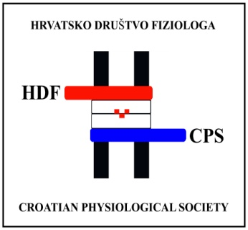 | HRVATSKO DRUŠTVO FIZIOLOGA  Zavod za fiziologiju i radiobiologiju  Veterinarski fakultet Sveučilišta u Zagrebu  tel: 01/2390-170; Heinzelova 55, 10000 Zagreb  contact: ines.drenjancevic@mefos.hr Ines Drenjančević
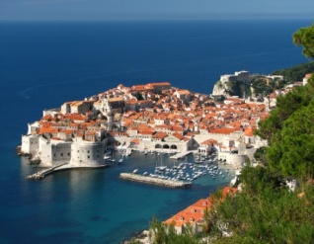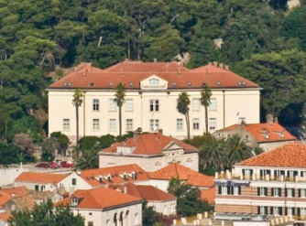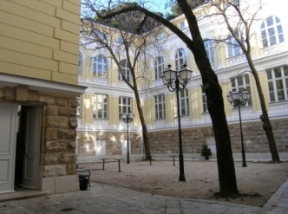
(source: CAAS brochure)

First call!

Dear Colleagues,
It is our privilege and honor to cordially invite you to join us at

4. Congress of Croatian Physiological Society and
2. Regional Congress of the Physiological Societies

21-24 September, 2017, Dubrovnik, Croatia

Venue:
CENTRE FOR ADVANCED ACADEMIC STUDIES (CAAS) IN DUBROVNIK
UNIVERSITY OF ZAGREB
Don Frana Bulica 4, 20000 Dubrovnik, Croatia
Phone +385 20 326 300; Fax. +385 20 326 390;
E-mail: office@caas.unizg.hr; Web site: www.caas.unizg.hr

Local Organizing Board – member of the Steering committee of Croatian Physiological Society
Ines Mrakovčić-Šutić, Faculty of Medicine Rijeka
Aida Salihagić-Kadić. Faculty of Medicine Zagreb
Željko Dujić, Faculty of Medicine Split
Ines Drenjančević, Faculty of Medicine Osijek
Aleksandra Dugandžić, Faculty of Medicine Zagreb
Mirko Hadžija. Institute Rudjer Boskovic, Zagreb
Ivana Jukić, Faculty of Medicine Osijek
Martina Mihalj, Faculty of Medicine Osijek
Vlasta Brunsko, CAAS, Dubrovnik
International Scientific Board:
Helena Lenasi, Ljubljana, Slovenia
Shane A. Phillips, Chicago, USA
Carlo Reggiani, Padova, Italy
Julian H. Lombard, Milwaukee, USA
Nandu Goswami, Graz, Austria
Otto Barak, Novi Sad, Srbia
Peter Nemeth, Pecs, Hungary
Giuliano Ciarimboli, Munster, Germany

Co-organizers and participating societies
Austrian Physiological Society
Slovenian Physiological Society
TBA
Faculty of Medicine Osijek, University of Osijek

Language
The official language of the Conference is English. No translation will be provided.

Registration fees:
seniors - 170 EUR;
PhD students, young researchers < 35 years, or up to 5 years of obtaining PhD degree - 100 EUR.
Accompanying person – 50 EUR

Registration fee covers:
• Opening session and welcome reception
• Participation in all sessions
• Program and conference book
• Coffee and refreshments on the conference days
• Conference dinner
The accompanying person fee includes:
• Opening session and welcome reception
• Conference dinner

Abstract submission deadline: 28th of June 2017 (online submission will be opened soon)
Information on abstract acceptance: 15th of July, 2017

Web page of the meeting:
http://hdf.mef.hr/index.php?option=com_content&task=blogcategory&id=75&Itemid=93
FB: https://www.facebook.com/events/598723693661351/

All correspondence should be sent to: ines.mrakovcic.sutic@medri.uniri.hr (mobile phone: 0038598546579) (alternatively: ines.drenjancevic@mefos.hr (mobile phone 00385-91-224-1406))

Topics:
  - Cell physiology
  - Environmental and exercise physiology
  - Clinical physiology
  - Physiology of aging
  - ….

Tentative Program
September 21, 2017/Thursday
Arrival date
13.00 – 19.00 Registration
18.00 Opening Ceremony,
Key Note Lectures
19:00 Welcome party

September 22, 2017 / Friday
08.00 – 18.00 Registration
09.00 – 12.00 Scientific Program
12.00 – 13.00 Lunch
13.00 – 16.00 City of Dubrovnik Tour (organized with a guide)
16:00-19:00 Scientific program
Free evening, social program

September 23, 2013 / Saturday
08.00 – 18.00 Registration
09.00 – 15.00 Scientific Program
19.30 Excursion to Ston and Conference Dinner

September 24, 2017 / Sunday
08.00 – 13.00 Scientific Program – Young scientists
13.00 – 14.00 Closing remarks

Accommodation:
TBA at the conference website

We would like that this symposium become opportunity for the members of regional physiological societies to communicate their research and to establish new collaborations.
You are warmly welcomed and we are looking forward seeing you in Dubrovnik at this fruitful scientific event but also at cultural and social activities!

For the Organizing Board
Prof Ines Drenjančević
President of CPS
Prof Ines Mrakovčić-Šutić
Vice-president of CPS

